Data Analysis Assessment

This project was completed with help of GitHub for a commit history as only 1 python file is to be submitted. Normally splitting these amongst different appropriately named files would help with the maintainability of the code.

Question 0: Initial Development
To make this program look a little cleaner python library OS is used to pause can clear the screen. This library is cross platform between windows and Linux and should provide a good UI for both.
When a user launches this program in the terminal, they are presented with a decision screen (Fig 1). From here, the user inputs a value presented on the screen, the system checks if it is one of the appropriate answers (Fig 2). If it is the value is parsed into a decision algorithm (Fig 3), calling the correct function based upon what the user is wishing to do.
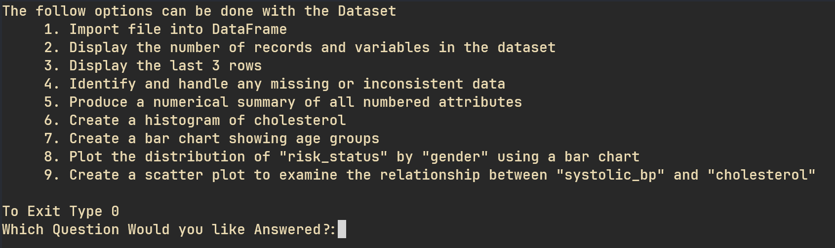
Figure 1 - Initial TUI that is present for decision making
Source - Author
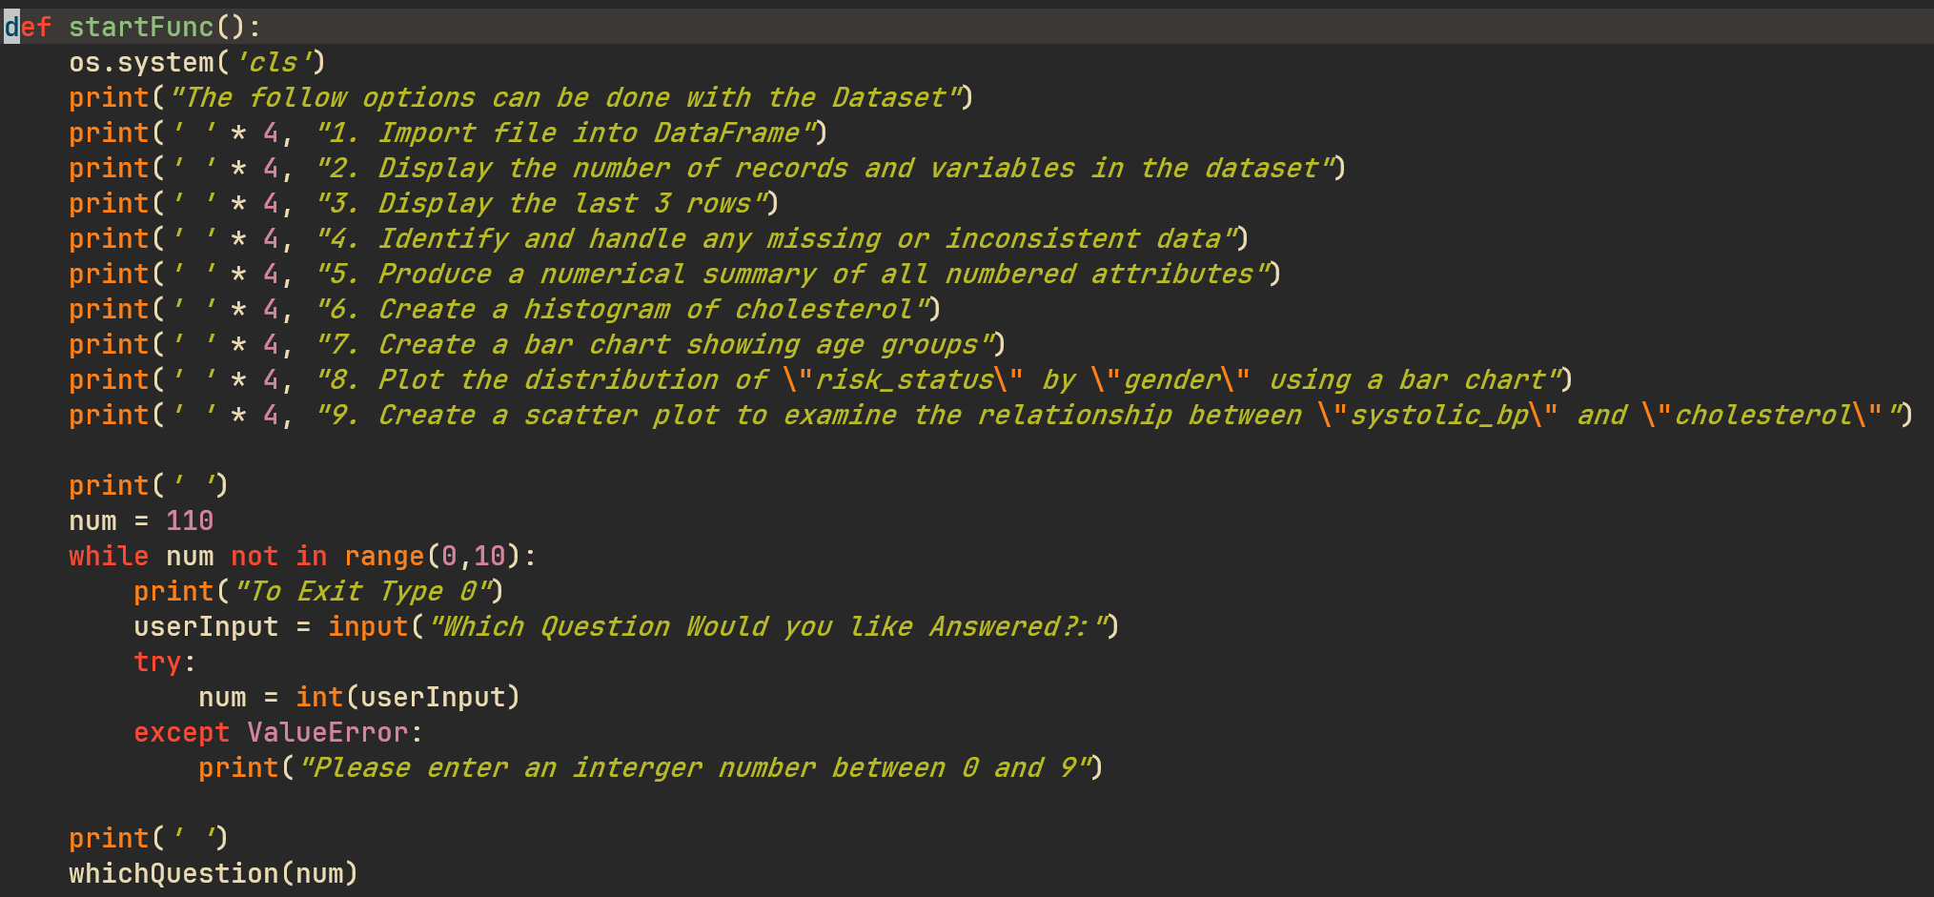
Figure 2 - Code to create the TUI and check value of the user input
Source - Author
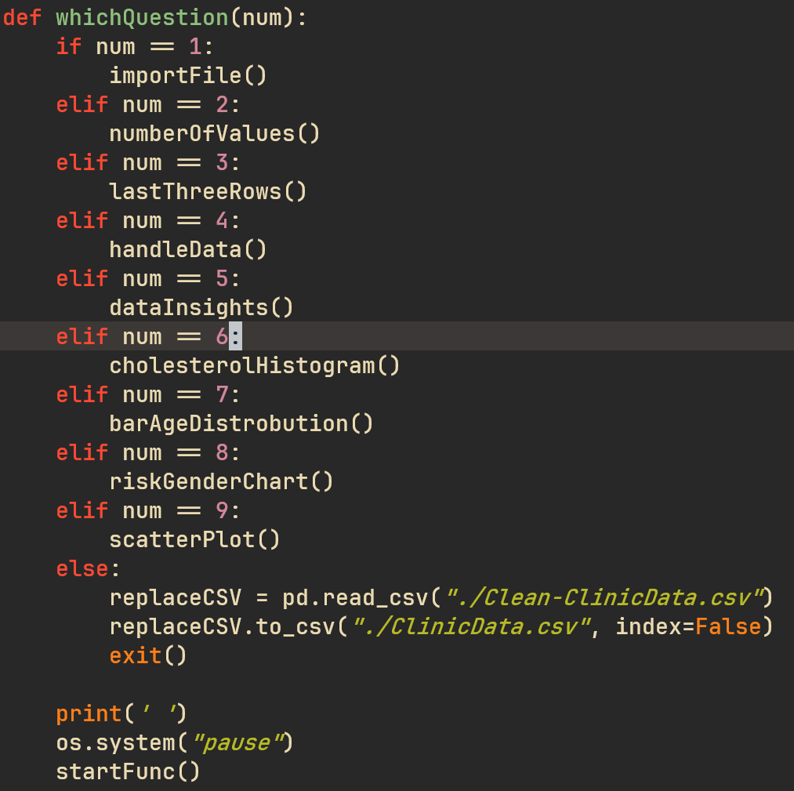
Figure 3 - Code that calls the correct functions based on the user’s input
Source – Author

Question 1: Parsing in the Clinic Data
When a user input 1 for their chosen query, the data present in the CSV file is parsed into a pandas DataFrame (Fig 4). This DataFrame is then printed onto the screen, showing the raw data in the file (Fig 5).
In the comment of fileName, and fileType is the option to have the user input the file’s name and type. This allows further flexibility in the file that can be imported into the program. The only downsides are it can currently only take CSV files and assumes that the data in the file follows the same naming conventions as the original file.
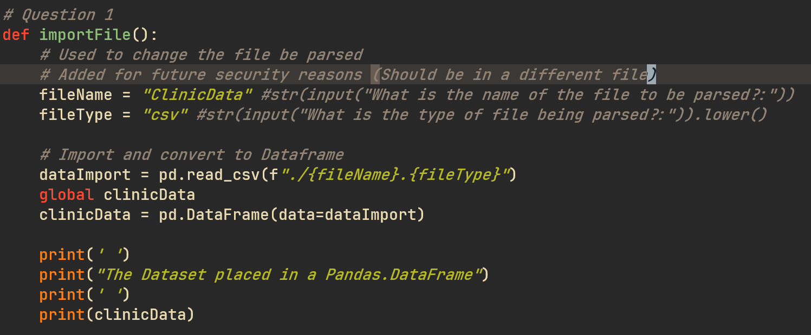
Figure 4 - Code too import the file
Source - Author
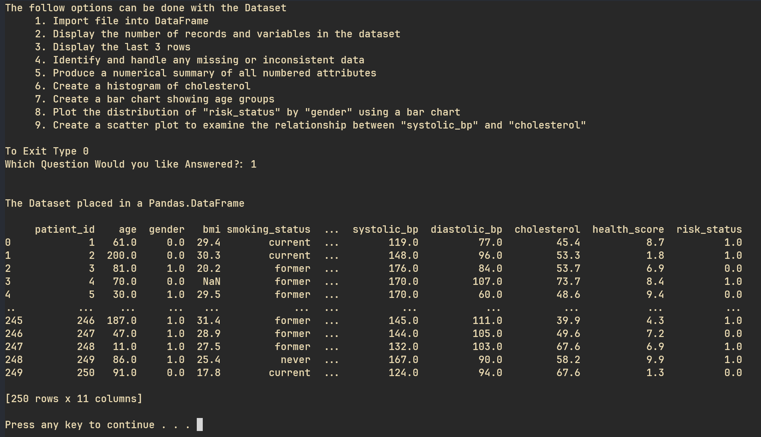
Figure 5 - User TUI of data import
Source – Author

Question 2: Display Number of Records and Variables
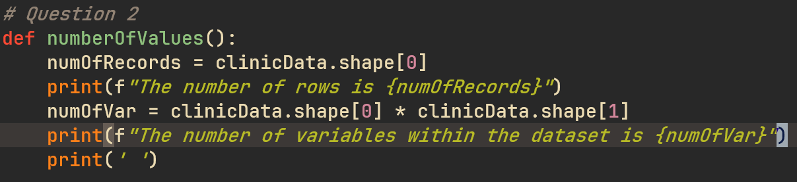
Figure 6 - Code for displaying number of records and variables
Source – Author
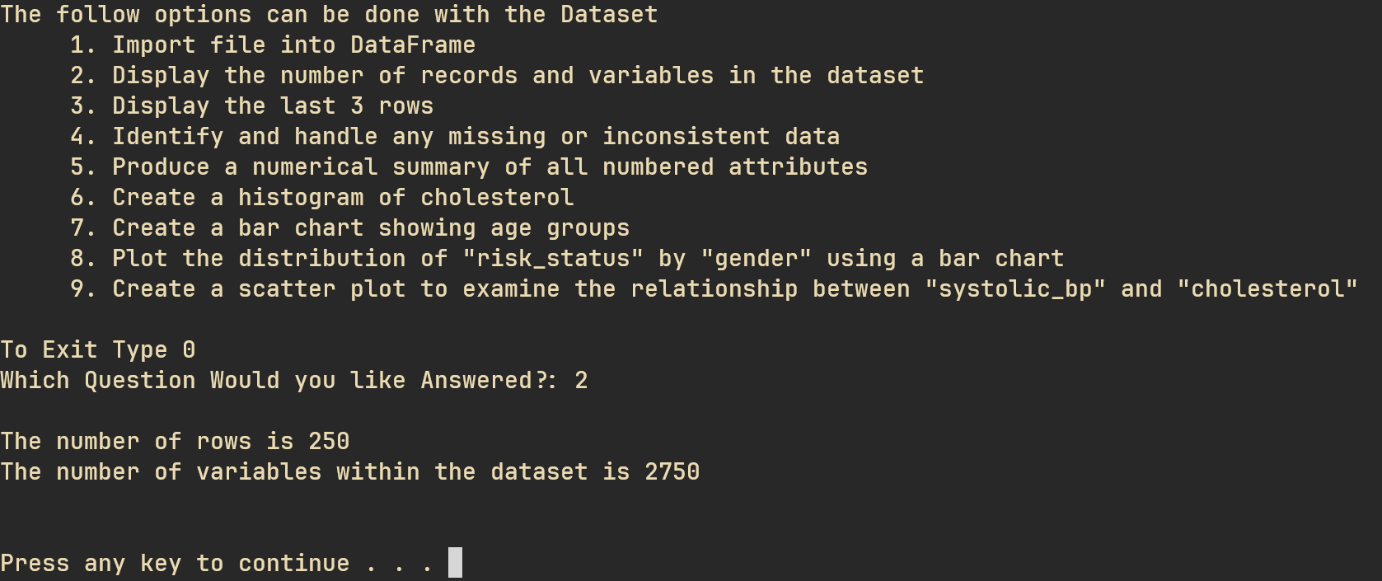
Figure 7 - TUI for showing the values
Source – Author

Question 3: Display Final 3 Rows
Uses .tail(3).
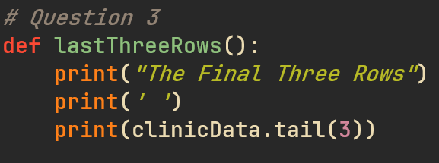
Figure 8 - Code for displaying final 3 rows
Source - Author
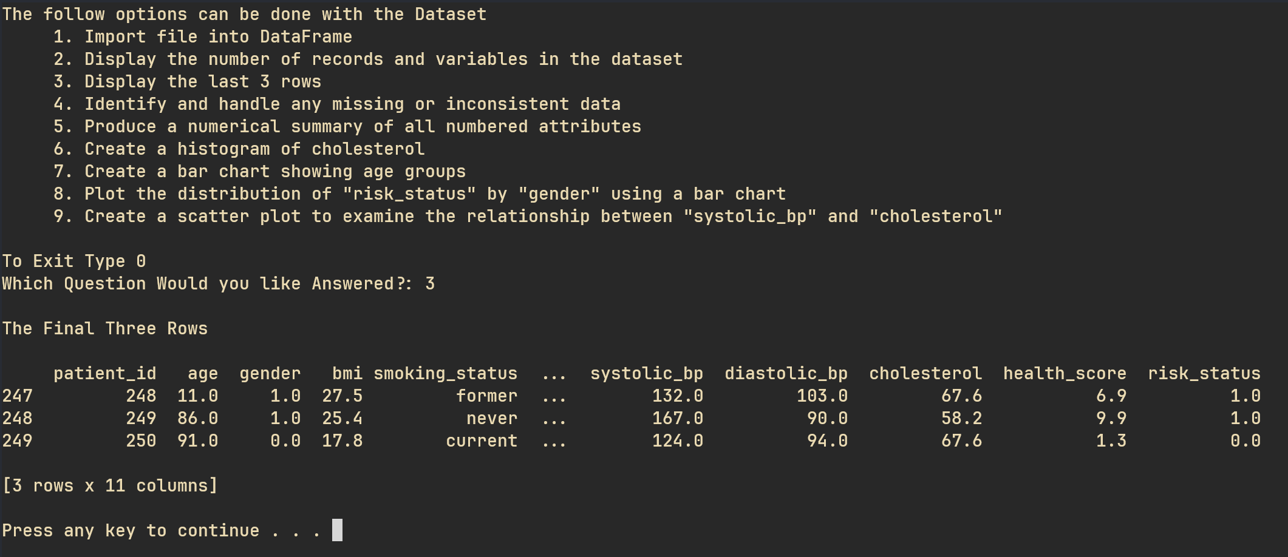
Figure 9 - User display of final 3 rows
Source – Author

Question 4: Cleaning Data
Here for each column the data was cleaned in a unique way. For critical values (age, gender, cholesterol, risk_status) a value was placed between the accepted minimum and maximum values. Else with the non-critical values they where just changed to 0.
If more time and data where present, a more complex solution of estimating an value based on existing values present within the dataset and in conjunction with a realistic value for other values present in that record.
Gender, since there is only 1 row of data that does not have gender placed in, it was decided to remove this record from the dataset.
Age was just checking if the ages were in an acceptable range. Eg. Age < 0 can be in the dataset, as such it was just change to 0 or age > than the maximum accepted age of 120 was changed to 120.

Question 5: Numerical Summary
A 4 number summary is a great way of gaining insight into the variety of data present within a dataset. If a user does this before cleaning the data (Fig 11 Currently) they will find a summary that contains some answer that are clearly wrong. I.E the maximum age being 200, as well as a BMI and exercise of -1.0 (Fig 12 Currently). However, this will draw out useful insights into the information presented within the database. These can include:
- Finding if there are large numbers of outliers. I.E very large maximums or very small minimums in comparison to the mean. A better way to do this would be to include the interquartile ranges (E.g. traditional 5 number summary). Further defining outliers within the dataset.
- Determining the weakest, strongest and average of the human health within the clinic Data provided
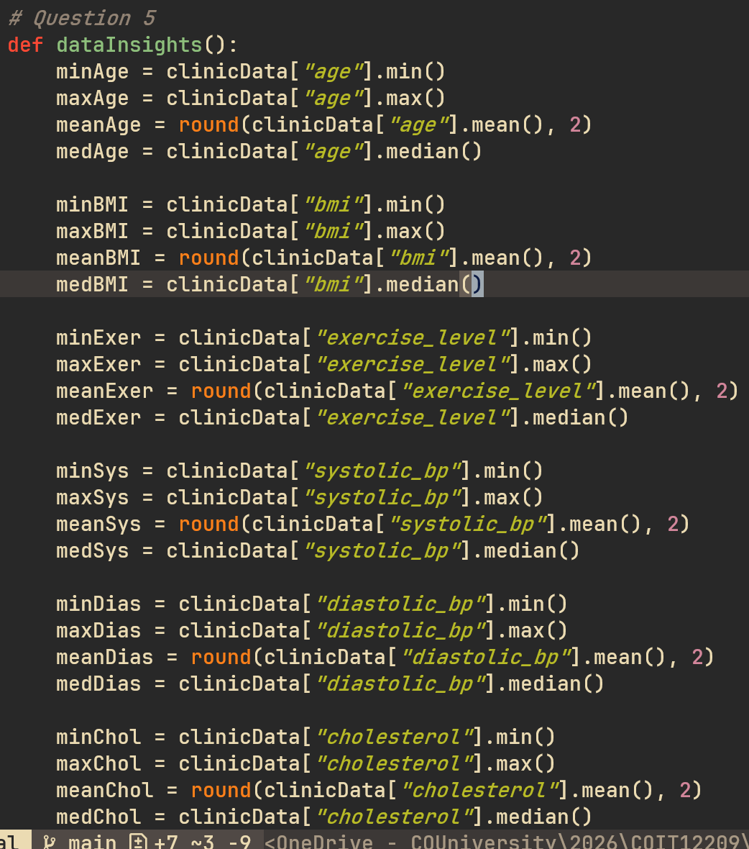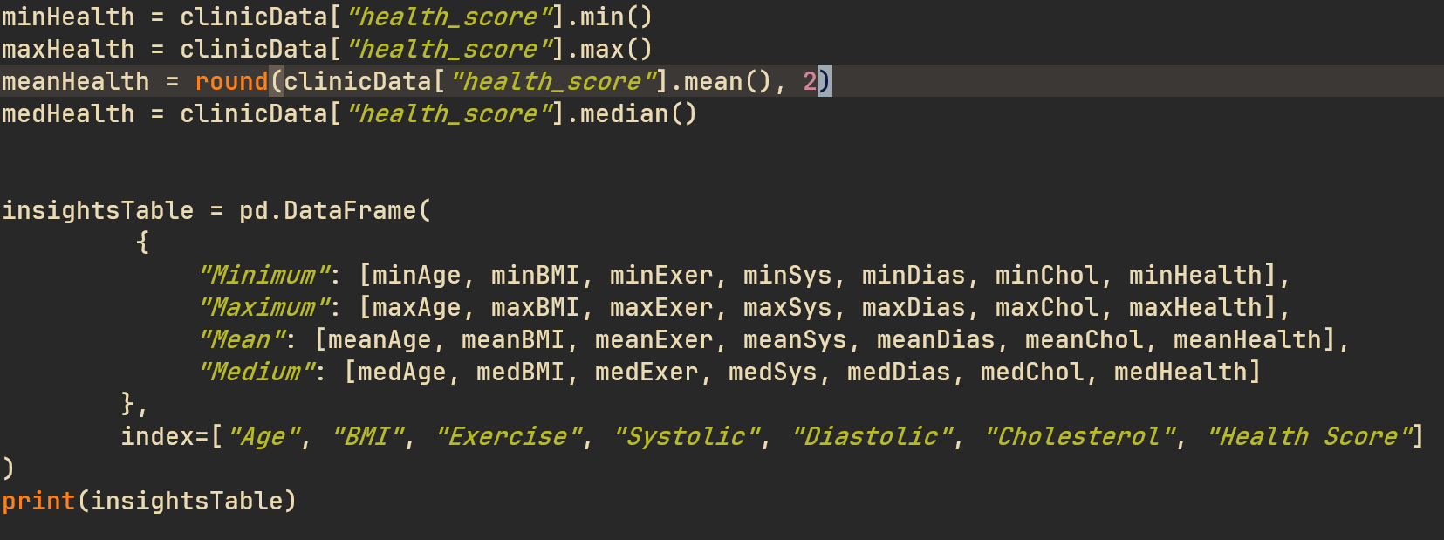
Figure 10 - Code for calculating a 4 number summary for each numerical column
Source – Author
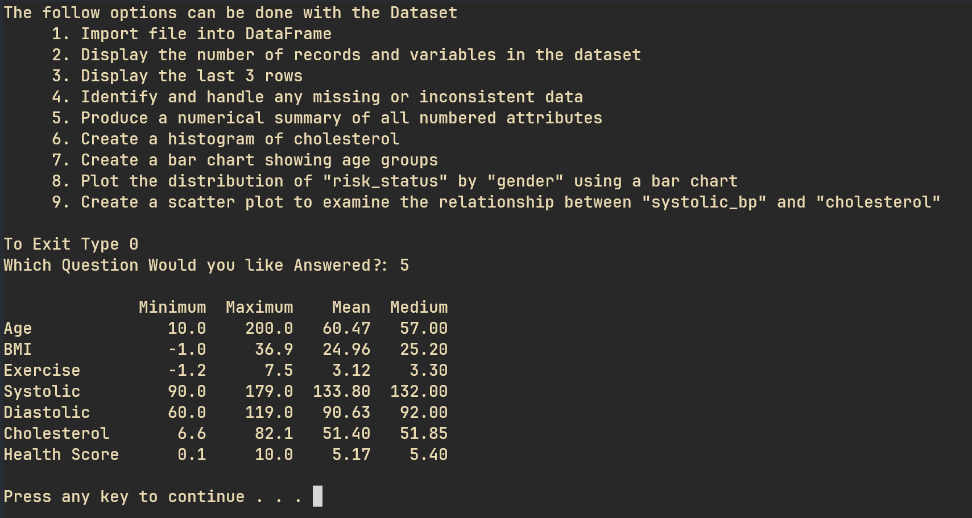
Figure 11 - Summary before clean
Source – Author

Question 6: Cholesterol Histogram
The frequency distribution in the cholesterol histogram can change widely with the number of bins that the developer wishes to include. The more bins the more bars and accurate the chart becomes. Here 20 bins was chosen as a middle ground between efficiency and accuracy.
As shown in Fig X the histogram appears to be normally distributed with the most number of people grouping around the 50 mark and failing off either side towards 0 frequency.

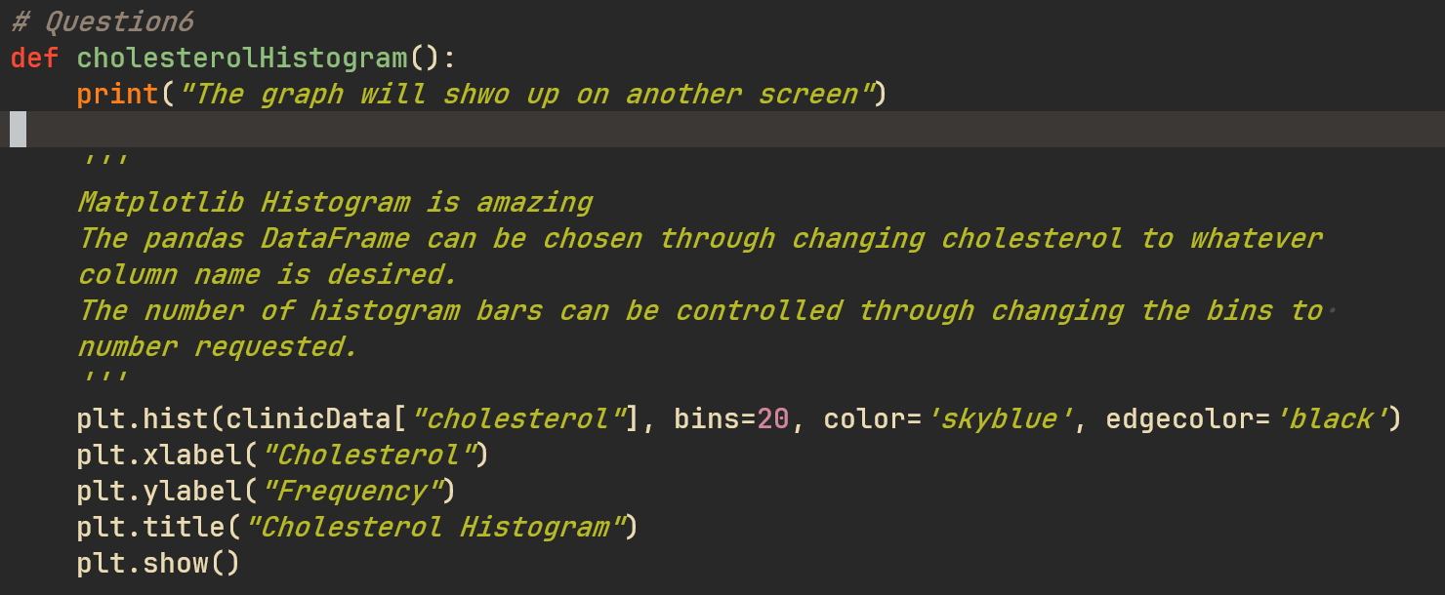
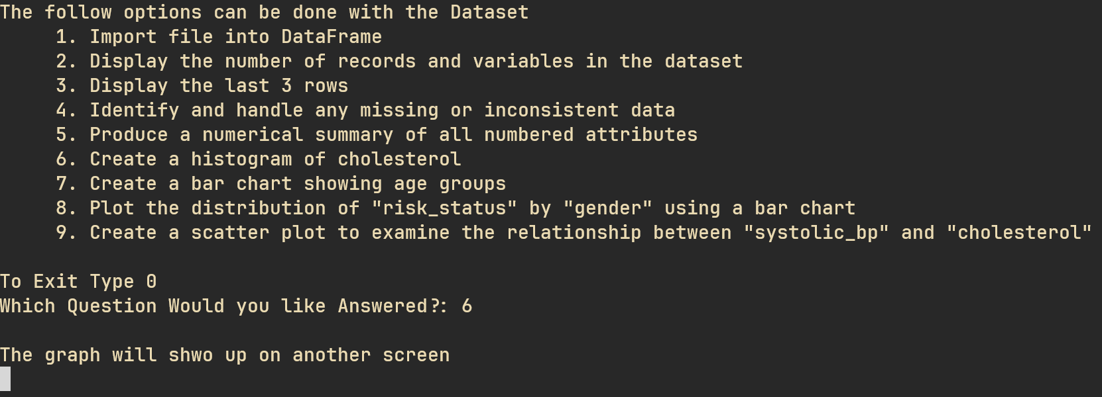
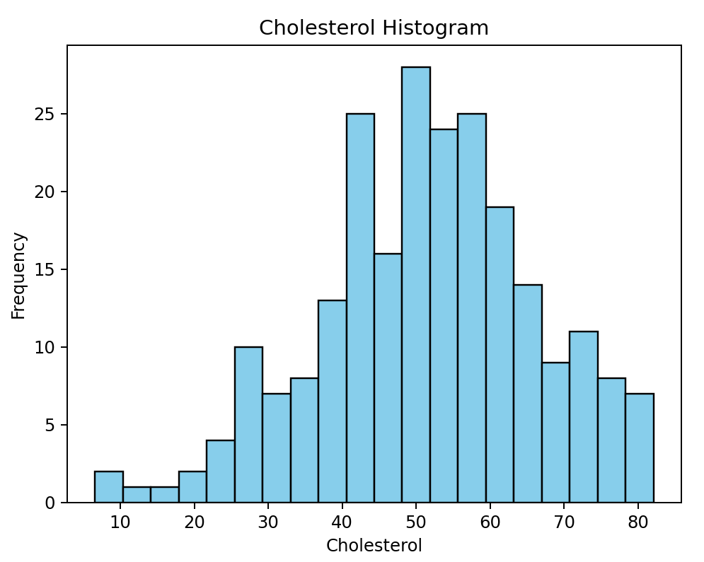

Question 7: Age Grouping Bar Chart
There is an extra grouping for people who forgot to clean the dataset before creating the graph. As even in the test dataset there is a record that do not contain an age. This just creates a visual direction in which the user can see any errors within the data.
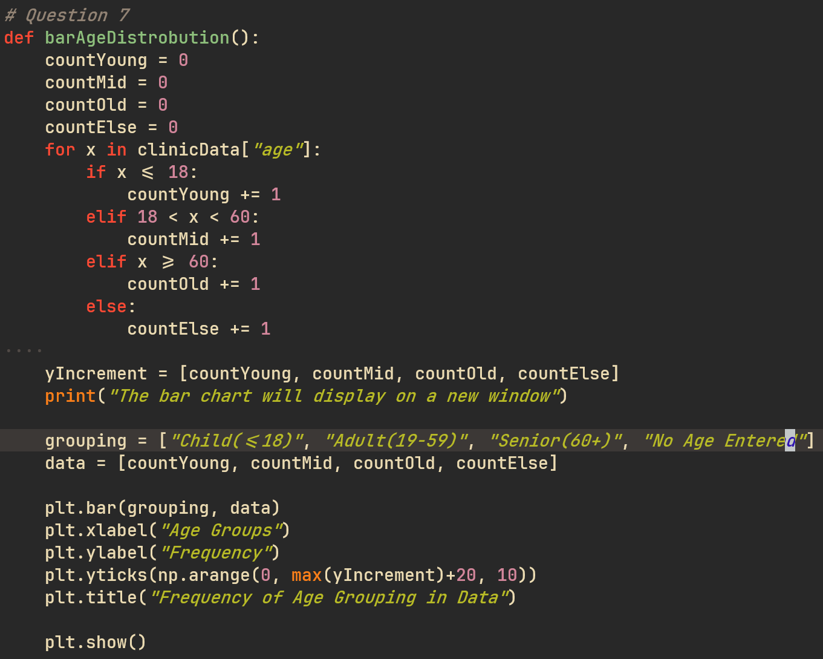
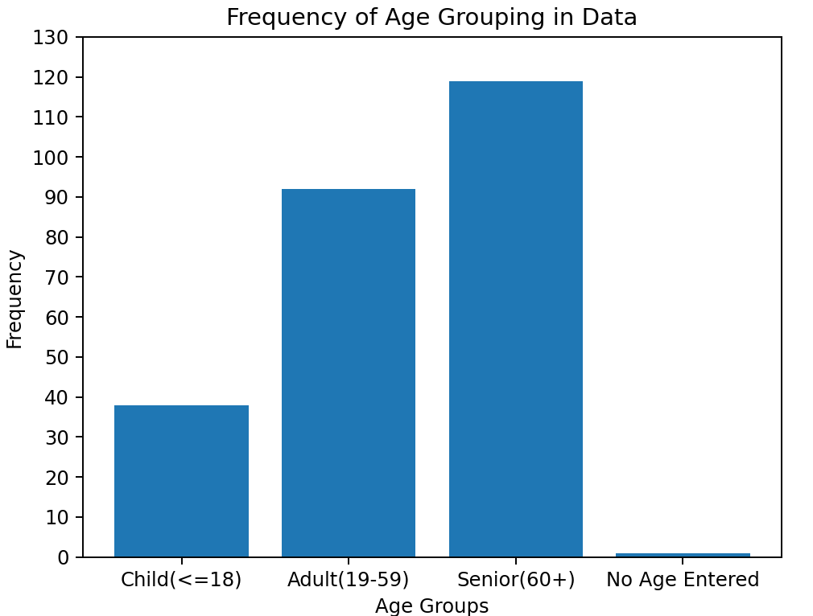
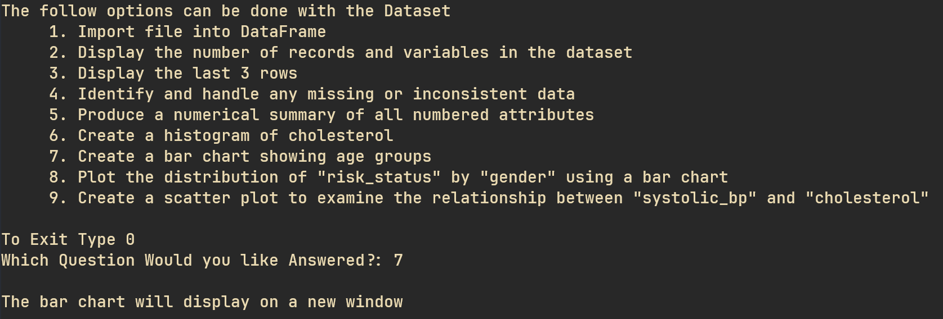

Question 10: Working with Health Data
When working with and around any health data there are numerous privacy concerns. Even with anonymised data, there can be enough identifiable information within a record that linked with other datasets can uniquely identify the person. As such the utmost care should be taken when accessing, transporting or utilizing the data. In addition to making sure that the consent of everyone’s data being used in this way understands the privacy risks taken when this will inevitably be leaked/hacked in some way.
Data security talking and how it would be bad if this data was not handled in a secure way.

If this data is being utilized as training data, I.E a machine learning algorithm to predict results based on data inputs, the biasing within the data must be considered. For example, using a population dataset based on white middle-aged men, and using it with old Chinese women there would be a clear representation and ….. bias towards the issues with the dataset.

